-In Dashboard – Whether shall we keep as all vessel as one option., and we need to keep one more tab for Fleet wise.

In Master Data
- We should have some checks not to repeat the same ranks.
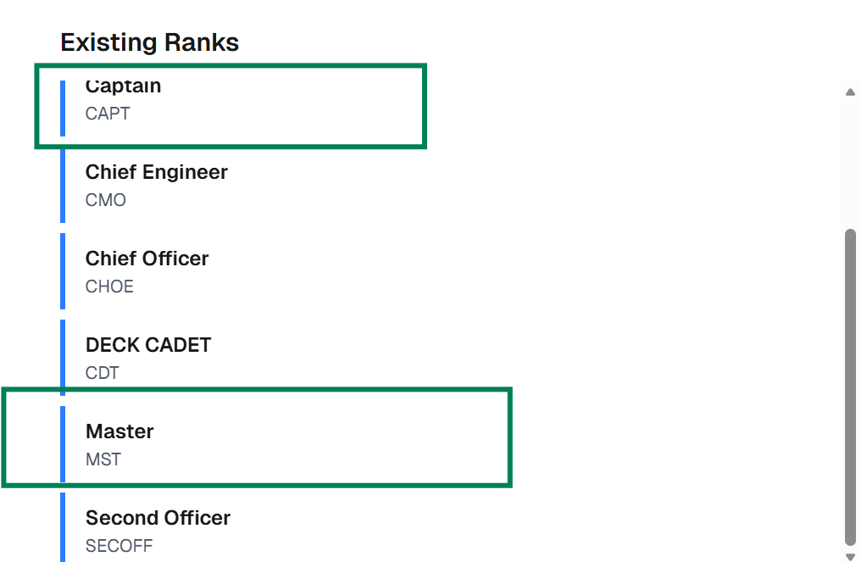

- Ports we need to add in back end
- Exchange, we need to fix. Just a suggestion for temporary we can ask the client to add either on monthly basis or weekly basis., for permanent or full fledge software we need to work how to proceed.

-Crew Management

- Rank – Shot name to be displayed in green highlighted.,
- 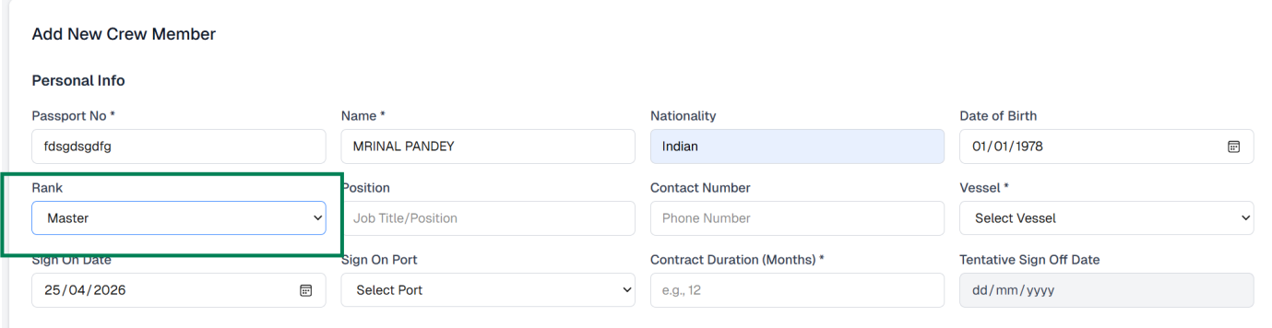
- As already discussed, either vessel name should be auto displayed based on the currency vessel name at the top or it should not be displayed at the top.
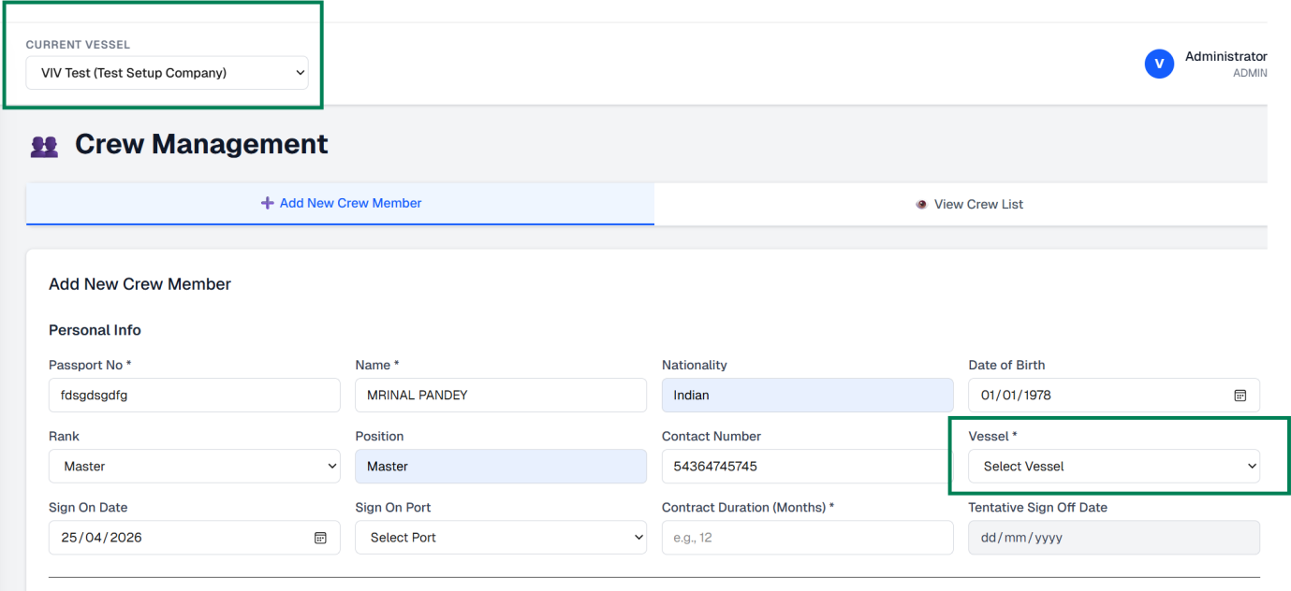
- Contract duration – We need to apply condition +/-1 Month for contract.
- Contract is successfully uploaded, We need to ensure the correct contract copy attached by reading the Name of crew mentioned in the PDF and verifying with the name we entered in system.

- Just tried one sample of uploading the Mst Mirnal Pandey contract., successfully uploaded., all the details mentioned are in order., I tried replacing with the CDT contract where the wages of the cdt is very low and other allowance is not available for CDT., Though it is successfully uploaded the other allowance column is unchanged and amount remains same of MST. This needs to be correct.

- Based on the contract copy, the name is amended in the crew list.

- Travel wages - Travel wages will be calculated from the basic wages., shall we keep somewhere in the below screen., if the admin approve the crew list along with the one day/ two day., in travel wages column instead of entering manually it should auto calculate based on the number of days approved by the admin. Travel wages will be applicable only during sing on or sing off.
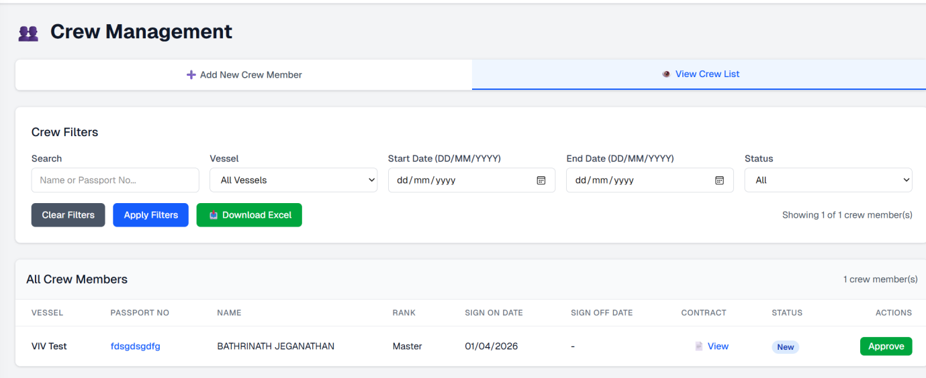
- Like same we should have for HRA also., it will be calculated based on the basic wages * number HRA days. It might come anytime based on the trading pattern of the vessel.
- Just for testing., I entered some number in HRA column and not saved. However, it is considered as finalization.

- In Below screenshot., I have added crew sing on, On March and April., however if I run the report for Jan, feb and March both the crew’s name is displaying and the earnings are calculated.
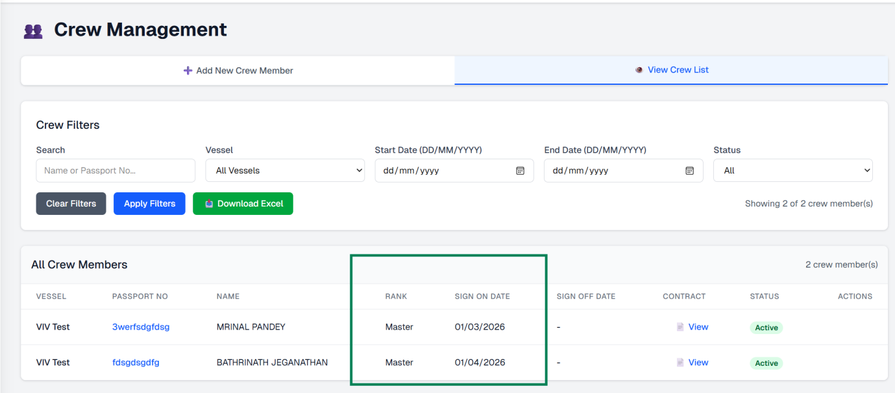

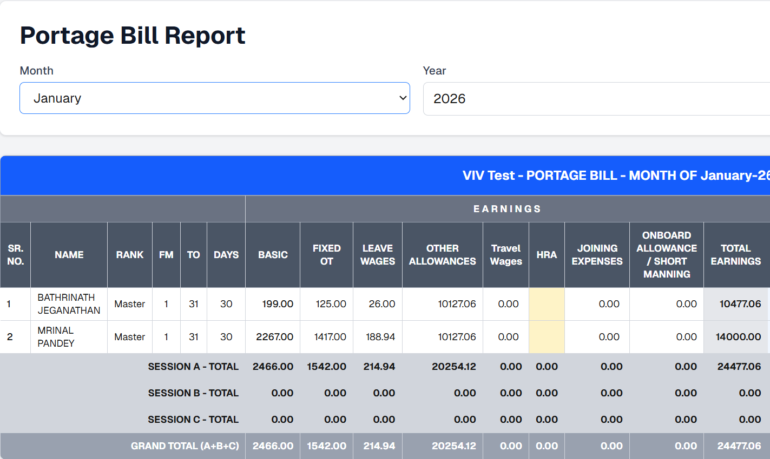

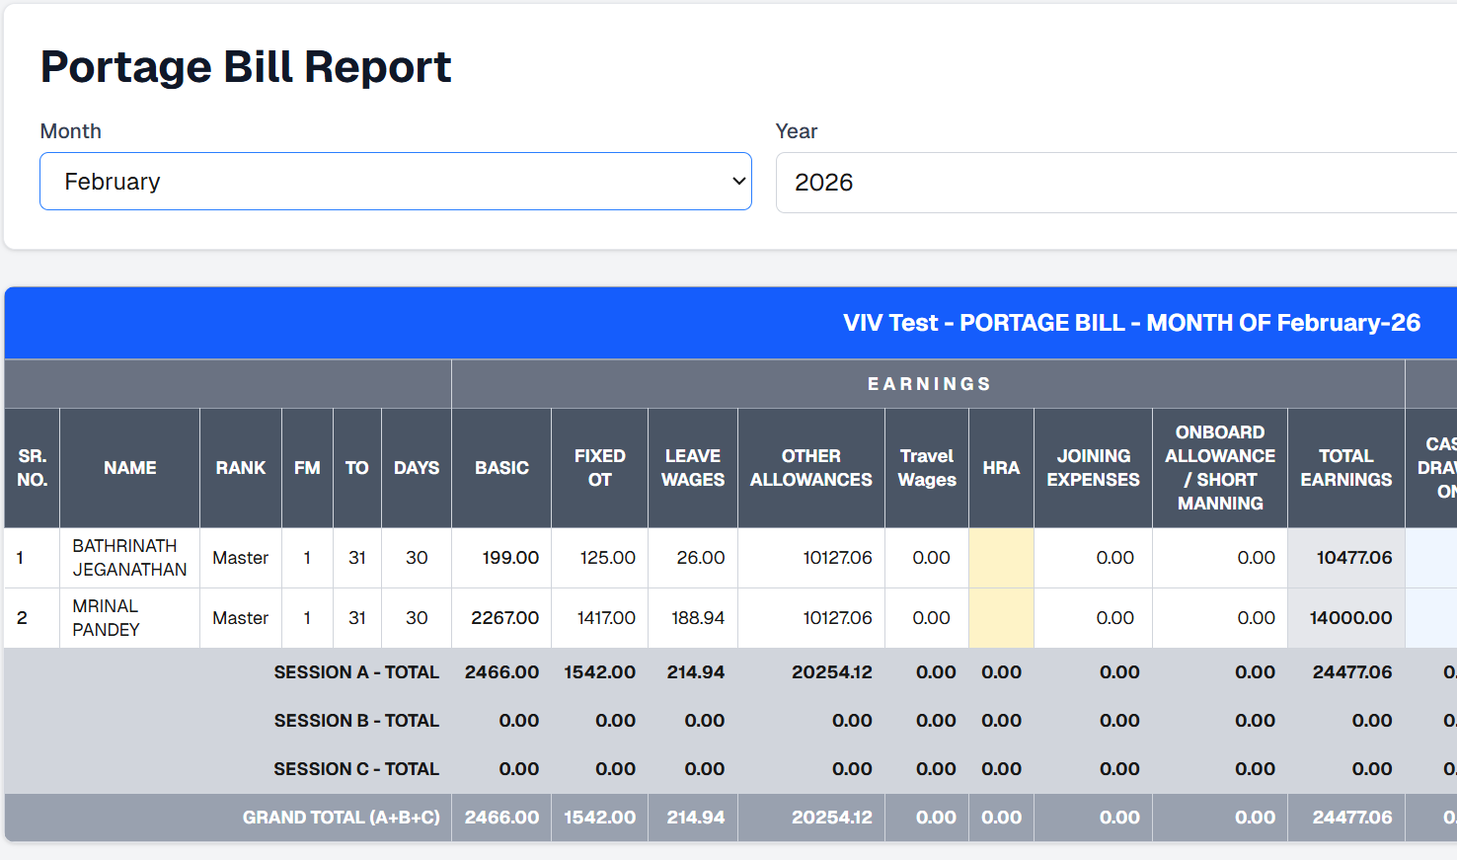

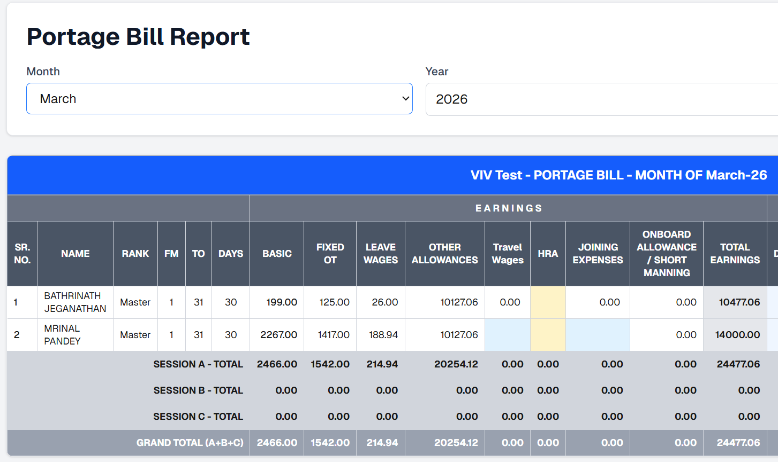

-Papa Rao – Crew added in March – His rank is not displayed., he singed on only 4th March – so 28 days his wages to be added instead it is displayed only 27 days.
-Though no one is added in Feb month report., just checked the PB for Feb, TO date is calculated till 31st., we need to correct the same.
-Victualling Number of Man days is perfect but we need to double confirm how the number of meals is calculated., I have not mentioned any time during sing on date.
-Victualing – If I run the report for Jan/Feb – It is not necessary to show the below crew., since they were singed on may be in the month of March/April.
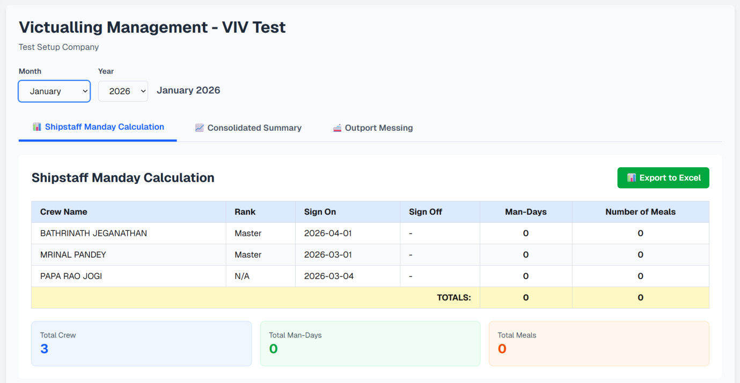

-Bonded stores – Once we click the Save in PB., then only the deduction amount is displayed in PB.
We need to change to owners/charterer
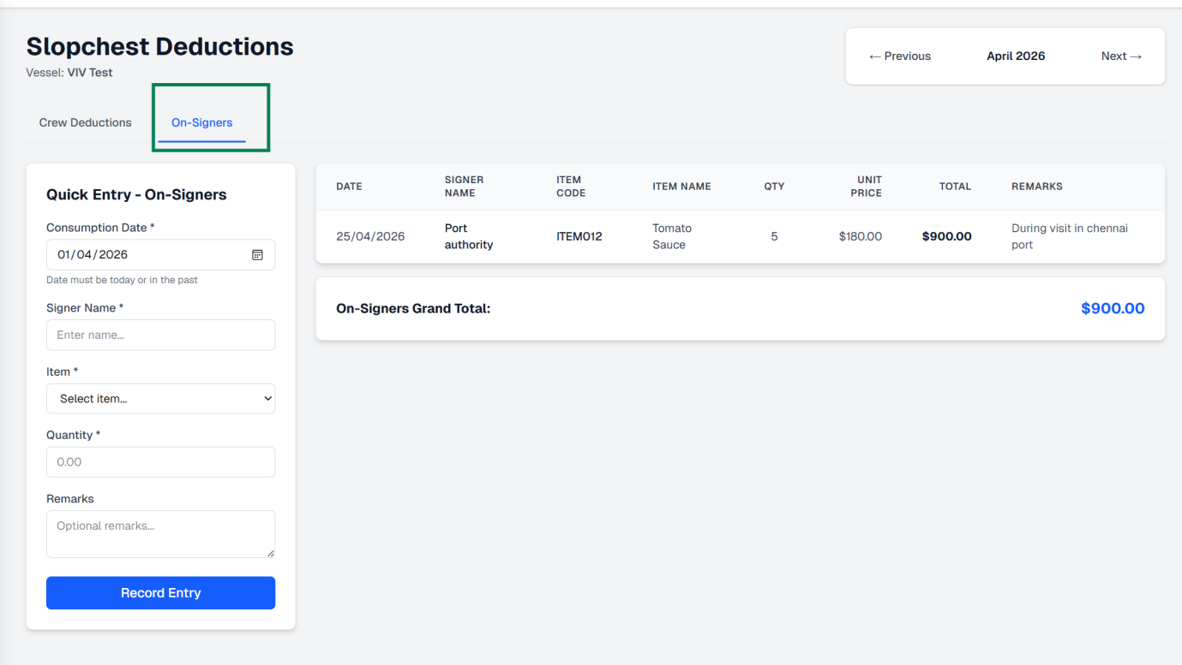

We need to work on the Inventory for Provision and bonded stores., how to upload the purchase invoice as well.

